Because I Could Not Stop for Death
Emily Dickinson
1830-1886

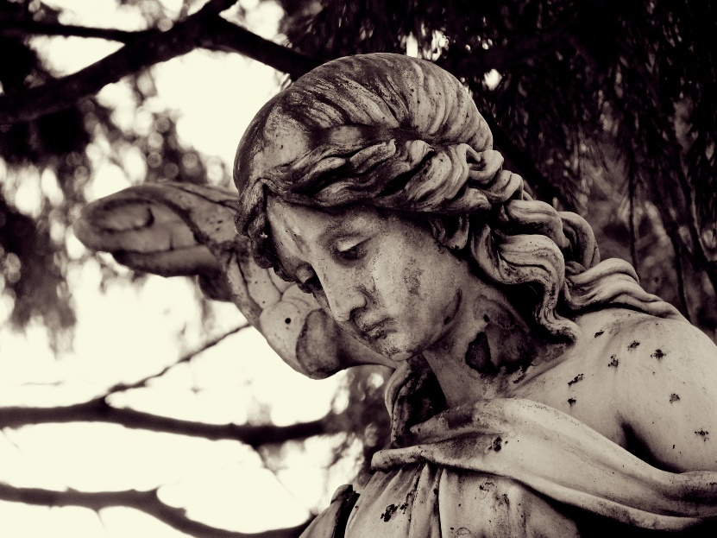
Because I could not stop for Death –
He kindly stopped for me –
The Carriage held but just Ourselves –
And Immortality.

We slowly drove – He knew no haste
And I had put away
My labor and my leisure too,
For His Civility –

We passed the School, where Children strove
At Recess – in the Ring –
1. Gossamer – very thin substance such as spider web or cobweb

2. Tippet – scarf like garment

3. Tulle – thin fabric, used for making tutus

4. Cornice – ornamental wood lining a room just below the ceiling

We passed the Fields of Gazing Grain –
We passed the Setting Sun –

Or rather – He passed us –
The Dews drew quivering and chill –
For only Gossamer₁, my Gown –
My Tippet₂ – only Tulle₃ –

We paused before a House that seemed
A Swelling of the Ground –
The Roof was scarcely visible –
The Cornice₄ – in the Ground –
Other words I did not know: Definitions

Since then – ‘tis Centuries – and yet
Feels shorter than the Day
I first surmised the Horses’ Heads
Were toward Eternity –

Comprehension Questions:
Answer in complete sentences.
1. What is being personified in this poem? How do you know?

__________________________________________________________________________________________
2. What is revealed about the narrator in the last stanza of the poem?

__________________________________________________________________________________________
Symbol | Meaning
1. The Carriage
2. The Children
3. | the end
4. The House
5. | onwards toward the afterlife

Paragraph Response:
What is the narrator’s attitude toward death in the poem? What literary devices help to create the tone? Explain their effects.

__________________________________________________________________________________________

__________________________________________________________________________________________

__________________________________________________________________________________________

__________________________________________________________________________________________

__________________________________________________________________________________________

__________________________________________________________________________________________

