For Heidi With Blue Hair
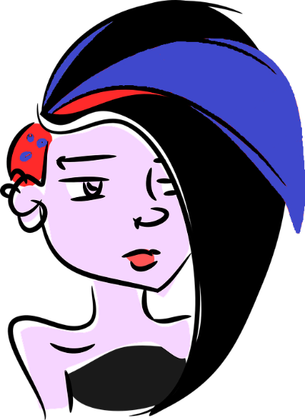
By Fleur Adcock

Building Background

What do you know about the term “punk”? Make a list of the connotations you think of:

Comprehension Questions:

- a). In what person (1st, 2nd, 3rd) is the poem narrated?

b). What can you infer about the narrator’s relationship with Heidi?

- What literary device is most present in the poem?

3.
Example: | Effect:
line:
line:
line:

4. a). Who opposes Heidi’s decision to change her hair colour?

b). Who shows solidarity and supports her decision?

Two Paragraph Response:

On a separate sheet of paper, write a concise, two paragraph mini essay answering the following prompt:

Consider Adcock’s use of imagery in the poem. How does it evoke empathy in the reader for Heidi? Hint: Identify uses of imagery throughout the poem and analyse how your impression of Heidi changes with each one.

