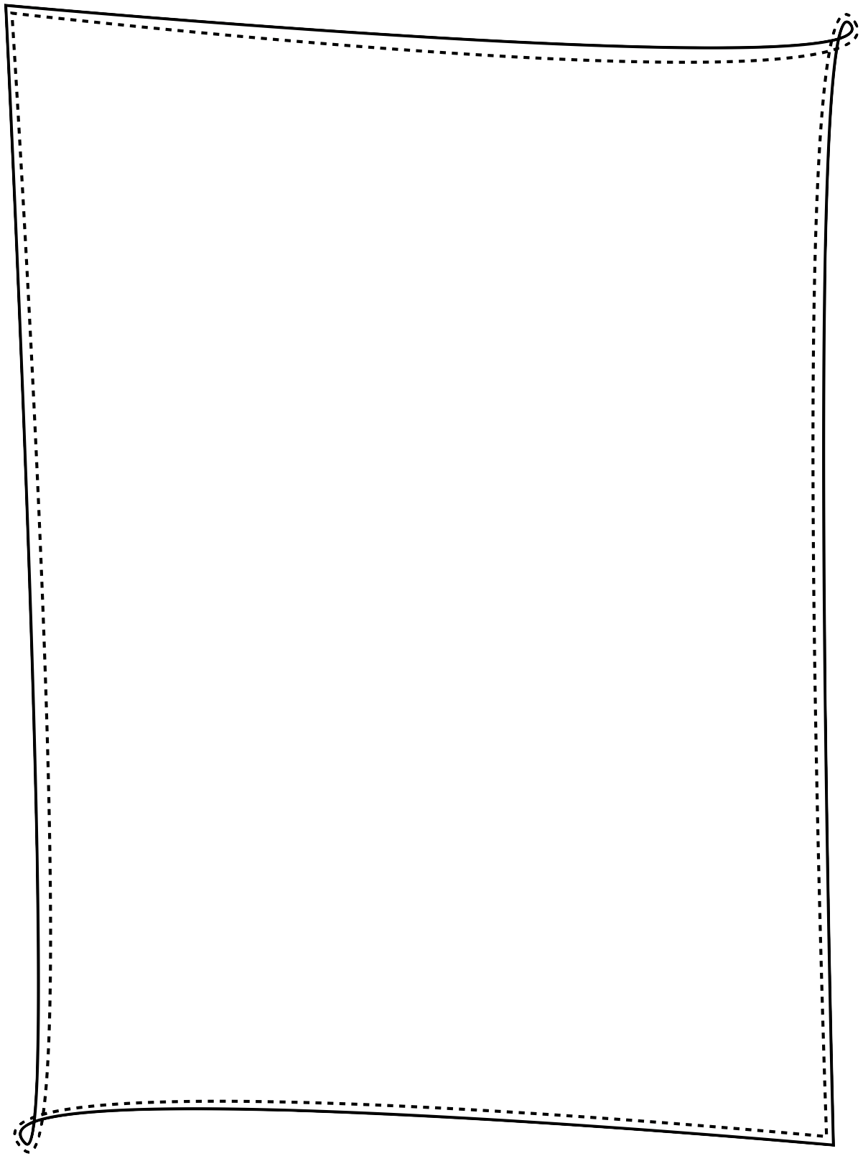

One Art by Elizabeth Bishop

KEY VOCABULARY
WORD | PART OF SPEECH | DEFINITION OR SYNONYM
1. intent
2. fluster
3. vast
4. realm
5. gesture
6. evident
7. shan’t

COMPREHENSION QUESTIONS

1. What kinds of lost things does Bishop list in the poem? Divide the list into two columns:
Literal Objects Figurative or Abstract Ideas

2. What is revealed to have been lost by the last stanza?

3. How does the author feel about this loss?

WRITING PROMPT: Two paragraphs

How does the repeated line in the poem change meaning as the poem progresses?

